Ruth, Naomi and Boaz
Reading: Ruth 2:17-23
So Ruth picked up grain in the field until evening. Then she separated the barley from the straw. She carried it back to town. Her mother-in-law saw how much she had gathered. Ruth also brought out the food left over from the lunch Boaz had given her. She gave it to Naomi.
Her mother-in-law asked her, “Where did you pick up grain today? Where did you work? May the man who noticed you be blessed!”
Then Ruth told her about the man whose field she had worked in. “The name of the man I worked with today is Boaz,” she said.
“May the Lord bless him!” Naomi said to her daughter-in-law. “The Lord is still being kind to those who are living and those who are dead.” She continued, “That man is a close relative of ours. He’s one of our family protectors.”
Then Ruth, who was from Moab, said, “He told me more. He even said, ‘Stay with my workers until they have finished bringing in all my grain.’ ”
Naomi replied to her daughter-in-law Ruth. She said, “That will be good for you, my daughter. Go with the women who work for him. You might be harmed if you go to someone else’s field.”

Thinking about the reading
In previous Bible readings we heard how Naomi’s husband and two sons had died when they were living in the land of Moab. She decided to go back to Bethlehem. Her daughter-in-law, Ruth went with her.
In Bethlehem, Ruth went out to the fields where the harvest was being gathered. She picked up grain that was left behind and took it home to make bread for Naomi and herself. In the fields, she met the man who owned them, whose name was Boaz. He noticed how good Ruth was to her mother-in-law, Naomi. He was kind to Ruth. Eventually they got married.
When Naomi arrived in Bethlehem, she felt that God had left her. But God was still working, and he led Ruth and Boaz together. Sometimes we might feel like Naomi, because things are difficult and we can’t see how God is working. It’s like holding one piece of a jigsaw. We can’t see the whole picture till we put the pieces together. But our God is faithful and we can trust him to look after us.

Prayer
Thank you, God. That we don’t need to understand everything. When life is good, you are with us. When life is hard, you stay with us. When life is confusing, you never leave us. Help me to trust you every day.
Amen.

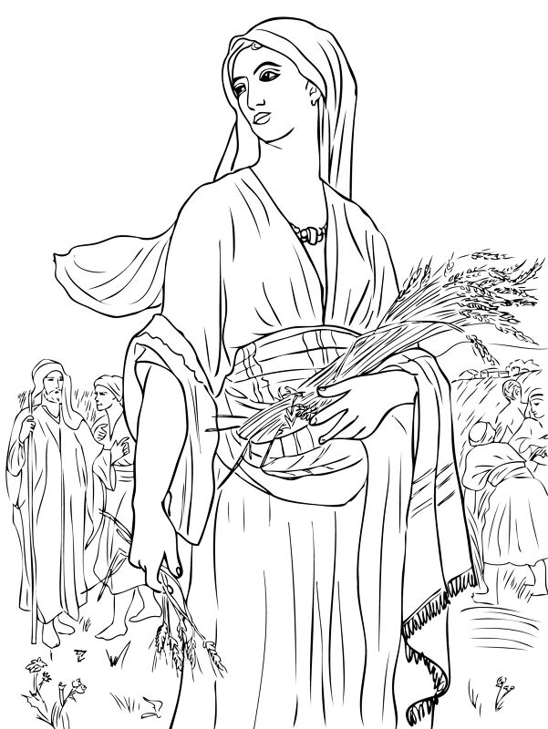

Cambridge Causeway

Summer 2026
Bible Study notes

The Story of Ruth
3. Ruth, Naomi and Boaz
Based on the teaching plan published by Count Everyone In.

